TEXT ANALYSIS PROJECT REPORT

Sentiment Analysis using YouTube Comments Dataset

1. Introduction
- Text mining extracts meaningful insights from unstructured textual data using NLP and machine learning techniques.
- In this project, sentiment analysis is performed on YouTube user comments to classify them as positive or negative. The analysis uses text preprocessing, TF-IDF feature extraction, and Multinomial Naive Bayes (MNB).

2. Dataset Description
- Dataset: YouTube Comments Dataset (UScomments.csv)
- Source: Kaggle
- Total Size: ~691,400 comments
- Used in project: 20,000 comments (sampled for faster execution)
- Type: Unstructured text

Feature Used
- comment_text: Contains raw user comments

Example Comments from Dataset
- “This video is amazing, I love it!”
- “Worst video ever, waste of time”
- “Nice content but audio quality is bad”

3. Text Mining Process (Pipeline)
Raw Comments → Preprocessing → TF-IDF → Feature Selection → MNB Classification → Evaluation

4. Text Preprocessing
YouTube comments contain noise like emojis, links, and mixed casing. The following steps were applied:

1. Lowercasing
All text was converted to lowercase.
Example:
“This VIDEO is AWESOME!” → “this video is awesome”

2. Removal of URLs and Special Characters
Example:
“Check this out!!! https://youtube.com 😍”
→ “check this out”

3. Tokenization
Text split into words.
Example:
“this video is great”
→ ["this", "video", "is", "great"]

4. Stopword Handling (Implicit)
Common words like is, the, and do not contribute much to meaning and are handled during vectorization.

5. Cleaned Output Example
Original:
“OMG this video is AMAZING!!! 😍🔥”
Cleaned:
“omg this video is amazing”

6. Stemming / Lemmatization
Convert words to root form:
running → run

5. Parsing (Tokenization)
- Sentence Tokenization → split text into sentences
- Word Tokenization → split into words
Used for structuring text before analysis.

6. Feature Extraction

1. Bag of Words (BoW)
- Counts word frequency
- Ignores order

2. TF-IDF
[
TF-IDF = TF × IDF
]
- TF → word frequency
- IDF → importance
Text is converted into numerical values using TF-IDF.

Example
Comments:
- “this video is amazing”
- “this video is bad”
TF-IDF gives:
- “amazing” → high importance in positive context
- “bad” → high importance in negative context
- “this”, “video” → lower importance

3. Term Document Matrix (TDM)
- Rows → documents
- Columns → words
- Values → frequency

4. Corpus
Collection of all text documents

7. Feature Selection
- Remove less important words
- Limited features to 5000 words using TF-IDF
- Reduce dimensionality
- Improve model performance

8. Multinomial Naive Bayes (MNB)

Why MNB?
- Works well with text
- Uses word frequency
- Fast and efficient

Assumptions
- Words are independent
- Multinomial distribution

Steps
- Build vocabulary
- Compute prior (P(c))
- Compute likelihood (P(w|c))
- Predict class

Example
Input comment:
“this video is amazing”
Model checks:
- “amazing” → strong positive signal
- Predicts → Positive (1)

Input comment:
“this is the worst video”
Model checks:
- “worst” → strong negative signal
- Predicts → Negative (0)

9. Worked Example
Vocabulary:
{team, win, match, election, vote}
Prior:
P(Sports) = 0.5
P(Politics) = 0.5
Likelihood:
P(team|sports) = (count + 1)/(total + V)
Prediction:
Choose class with highest probability

10. Sentiment Analysis

Types:
- Lexicon-based
- Machine Learning

11. Lexicon-Based Sentiment
Steps:
- Tokenize
- Match words
- Assign scores
- Sum scores
Example:
good = +2
bad = -2
Since dataset has no labels, sentiment was generated manually.

Word Lists Used
- Positive: good, great, amazing, love, awesome
- Negative: bad, worst, hate, poor, terrible

Example 1
Comment:
“this video is amazing and awesome”
Score:
+1 (amazing) +1 (awesome) = +2 → Positive

Example 2
Comment:
“worst video, I hate it”
Score:
-1 (worst) -1 (hate) = -2 → Negative

Example 3
Comment:
“good content but bad audio”
Score:
+1 (good) -1 (bad) = 0 → Positive (by rule)

12. Machine Learning Sentiment
- Convert text → TF-IDF
- Train MNB model
- Predict sentiment

13. Python Implementation (SKLEARN)
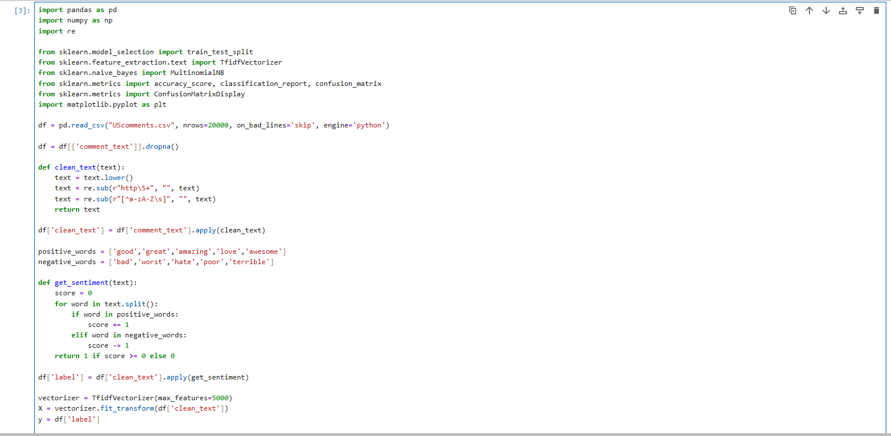
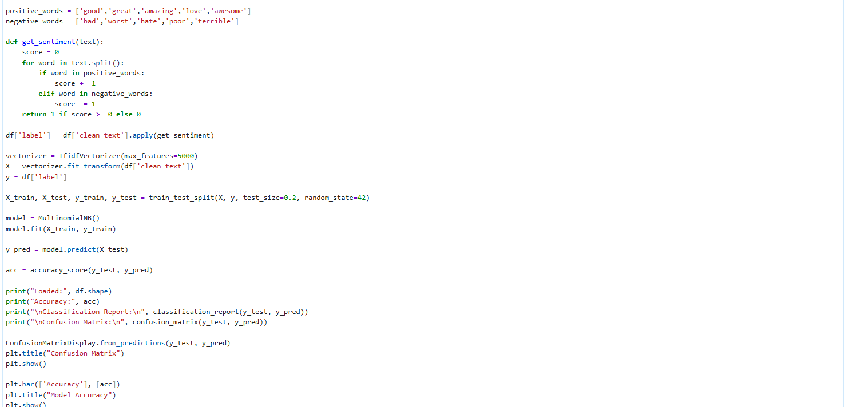

14. Output Screenshots

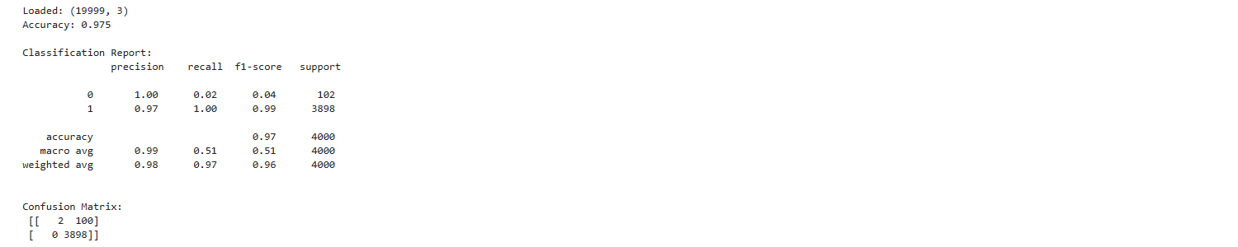

15. Graphs

Confusion Matrix Plot
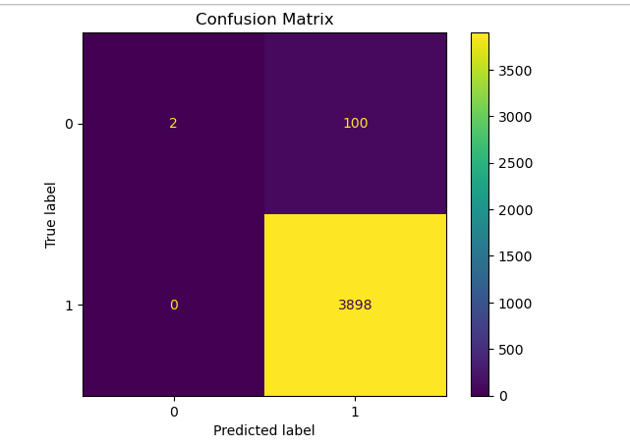

Accuracy Visualization
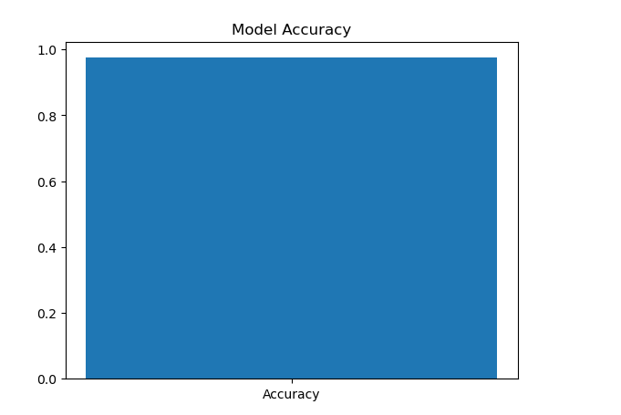

16. Observations & Conclusion
- Majority of YouTube comments are positive
- Dataset is imbalanced
- High accuracy due to dominance of positive class
- Model struggles slightly with negative detection
This project demonstrates how real-world YouTube comments can be analyzed using NLP techniques.

Key Outcomes
- Raw comments were cleaned and processed
- TF-IDF converted text into numerical features
- Sentiment labels were generated using a lexicon approach
- Multinomial Naive Bayes model classified comments effectively
- Model achieved high accuracy (~97%)
The project highlights the effectiveness of combining preprocessing, feature extraction, and machine learning for sentiment analysis on large-scale text data.

